* 1. **Bilateral GC Implant**

Day before surgery

Have your intra-oral cannula (IOC) and colder coupler ready and place it, along with your choice of tall or short skull screws, into cetylcide in a metal tray overnight. If you’re extra wary toss in your dental drill bits.

Double check that your electrode drive is ready. It might be a pain, but it truly helps to know which electrode is which when you’re comparing either side or seeing dead channels.

Finally, make sure your communal and definitely communistic surgery tray has been autoclaved and isn’t missing any doodads. Speaking of communism, make sure the Ketamine/Xylazine (KX) cocktail bottle has enough for your surgery, and as a courtesy to others, for any other activities involving ketamine that day.

Day of the surgery

1. Print two brand new surgery sheets (one for your records and one for the labs).
2. Fill out red surgery card from the vivarium, weigh your rat, and bring it into the surgery suite.
3. Grab a surgery coat, a surgical mask, and some of the single use gloves.
4. Let your rat chill in the surgery suite while you pull up KX, alloxate, lidocaine, ringer’s solution, and penicillin.
5. Now let the isoflurane gas induction chamber warmup by pushing down the green plunger on the syringe tip, then pressing induction and deliver on the screen.
6. While that’s going on get out 2 x iodine wipes and 2 x alcohol wipes, 2 x yellow needles, and the prepackaged scalpel blade on the shelf.
7. If you’re feeling ready and relaxed, now you can put some gloves on and scoop up your rat and place it in the iso-chamber. Be sure to keep a few fingers on the lid to stop your rat from escaping and your Zen from being ruined.
8. Now wait until your rat stops writhing and slumps down. Give it a good 10 seconds and tilt the box a bit. If she’s down, take her out and inject her intraperitonially (IP) with the KX induction does. (Hint! Be quick with this!)
9. Put her back in the home cage without the cage part but with the lid. (Now is a good time to go get coffee and brag about how well your surgery is going).
10. After you come back, check to see if your rat is down for the count (asleep) by taking it out of the home cage and putting it onto a brand-new diaper pad on the surgery table and giving her toe a pinch.
11. If 30 minutes have passed since the induction dose of KX, she’s withdrawing her leg to the toe-pinch, go on and give one of the KX boosters IP. If it’s still not working after 15 minutes give another boost. (Something is wrong if this isn’t working.)
12. Now you can get on to the real bits of the surgery.

The real bits of the surgery

1. Now using the Wahl **clippers** in the drawer shave a football-shaped pattern onto the top of the skull. This will point up right between the eyes and to the bony bump on the back of the head. I like to do this over the trashcan and shave the hairs directly into it. AVOID getting hair in the eye. This is a big no-no.
2. Take your shaved rat and place it gently yet firmly into the stereotaxic stage, this is a good time to give some **saline**, **alloxate**, and check for a **toe pinch**.
3. If your rat is like my rat, then you’ll want to place the **ear bars** at one or two deviations from the 10 on the ear bar meeting the 5 on the stereotax marker. Then place the animal into that one and fix the second one to match. (Make sure this is stable, level, and something no one would be suspicious about.)
4. Secure the two front teeth on the **head holder** and gently pull away and secure the screw.
5. **Clean the incision site** with iodine and alcohol. THEN put eye gel onto the rat.
6. Inject **lidocaine** either into two sites on the scalp or just one and wait for ~5 min. (Good time for a sip of coffee!)
7. Using a scalpel, create a clean **incision** (please not multiple incisions), rostral to caudal, that is large enough to expose the area of operation.
8. Use the head wound **retractors** to pull the skin to the sides and expose the skull. Make sure you’re actually getting under everything and not just the top layer. You should be able to see the sutures of the skull.
9. Now get your lights ready. Make sure the **eye gel** is on, so you don’t roast the eyeballs. (Ring light available. To use as well as gooseneck lights.)
10. Use the head bar to make the **skull level**. Align the front spike with bregma, and the middle with lambda as shown below:

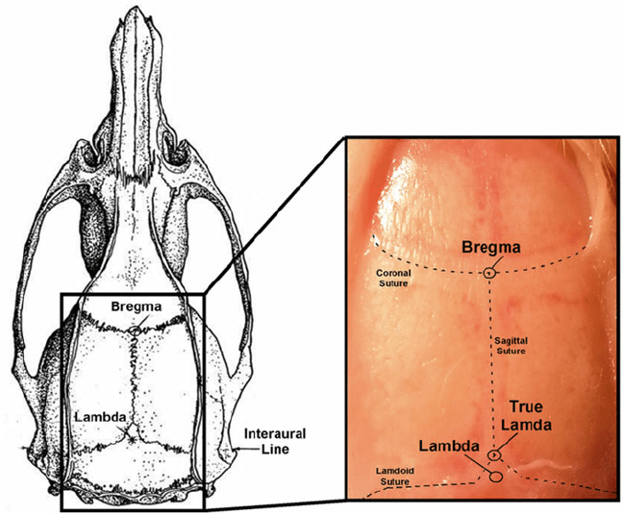

1. Using the spatula, make **IOC pocket** by finding the ridge on the lateral part of the skull and gently pushing the tissue off on the other side. Remove the ligament connecting the muscle off the ridge and below the bone to create a small pocket about ½ the length of the spatula.
2. Attach one of the needle tips (yellow) to bar mount to discern position of bregma. Mark it in the surgery sheet and calculate the **GCL and GCR coordinates**. Lower the needle tip over the GC coordinate and use the cauterizing tool to mark the location on the skull. Repeat with the other side.
3. Use the small drill bit LA¼ to create 4-5 shallow holes for **skull screws** as depicted below. About half the size of the small drill bit tip. Screw in each screw using a screwdriver and forceps, just until stable in the skull.
4. Now **RECHECK** your coordinates. Grab the big burr LA2 and get to making small donuts around the coordinate marker. Notice the GC is on a slope of the skull demarcated by the ridge on the skull that carries the jaw muscles.
5. You’ll need to **move** those muscles away like you did with the IOC pocket, or you can nudge it and cauterize away a little bit of the tissue.
6. Go slowly until you get the hang of it. Faster **drill** speeds = less harsh bite. So really slam the pedal down and lightly tap away with the drill bit.
7. Use a von Graefe knife to slice up the **dura** and the curettes to pick out any bone.
8. Now carefully **repeat this** on the other side. I recommend using a fine digital caliper to measure the distance from your craniotomy to the marker for the other side as well as the distance between your electrodes.
9. Make sure to **soak** up any liquid on the brain or around the craniotomy at this point.
10. Now prepare your **electrodes** for going into the brain.

Electrode Implants

1. Using either a brush or 0.5mL syringe put the tiniest drop of **Vybrant Dil** onto the tips of the electrode bundles. This ensures you can find out what the heck you recorded later on.
2. Using the alligator clip adjustable holder or the 3D-Printed implant tool **attach** your drive to the stereotax.
3. **Center** your bundles over the implant locations.
4. **Drop down** to the height of the brain such that the tips of the electrodes are touching the brain.
5. Record the D/V measurement and now begin **lowering** your electrode to -4.4mm from the surface of the brain over the period of 30 minutes.
6. Using **Kwik-Cast** mixed in a weighboat or with the applicator tip apply the green goo to the craniotomy. The skull around this area NEEDS to be dry.
7. Now using fine and medium curved forceps tie the **ground** wire around the ground screws.
8. Using **dental cement** build up a central pillar to the drive body and let it cure for a few minutes (coffee time).
9. Gently add another layer of dental cement around the drive and wait a little longer. Now unscrew or unclip the drive and **lift** of the stereotaxic holder.

IOC Implants

1. Remove **IOC supplies** from cetylcide into a saline jar.
2. Use bead sterilized forceps to insert a cut section of **silicone tubing** from the acetone container and affix it onto the IOC connector mount. Use a drop of vetbond on the window of the connector to secure the tubing in place.
3. Now put a **yellow needle**, tip to the washer, into the IOC and place it on a clean kimwipe.
4. Use the mouth **retractors** and small wound retractors to make the mouth open up wide.
5. Using the needle as a guide, **insert** it with the bevel facing towards the side of the second molar up into the flesh aiming towards your IOC pocket above.
6. Connect the silicone tubing and connector onto the IOC and begin the process of **dental cementing** the IOC in place and affixed to the drive body.
7. Once cured **check** around for any places that need filling in.
8. Now give all remaining saline, **penicillin**, and love.

Post Surgery

1. Prepare a new cage with soft bedding, wet food, water, and an enrichment packet as a pillow. Make sure your surgery cage card is filled out and return the animal to the vivarium.
2. Clean up after yourself and autoclave the trash and surgery tray.
3. Weigh your animal everyday post-surgery for a week and regularly clean cage, flush IOC and keep an eye on health.
4. For 2 days after surgery give meloxicam. The day after surgery give penicillin.
5. If your animals weight drops below 85% pre-surgery weight you cannot water deprive them and must nurse them back to above this threshold.